From my personal point of view, I think everyone in group Foxhound all did a good job on what they were assigned with. I did the IT technology part for my group . I chose to talk about the content of clouds, services and servers, cyber-security, blockchain and cryptocurrencies and natural language processing and chatterbots. Everyone in our group has got an equal task and everyone is willing to take on the tasks what they assigned with.

Each of us helps each other. When someone has any doubts about the task, someone immediately stand out to answers it. We trust each other and we all finish the task on the stipulated date and deliver it to the person who finalized the task. In conclusion, I am really honored to join this group Foxhound. Everyone is kind and helpful when needed. Through this assignment, It not only increased my opinion of IT, but also made me acquainted with this group of friends.

 I did my task.

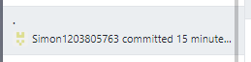I fixed some problem of my task.

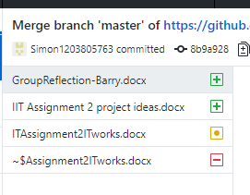I read other’s task.

Assignment meeting

16/04/2018 : We finished our team profile and build the group website. We let team members choose what they want to do .

23/04/2018: We discuss together about the IT field and IT work. We find out what should we done within 3 days.